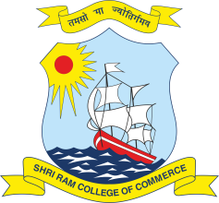 | SHRI RAM COLLEGE OF COMMERCE University of Delhi, Maurice Nagar, Delhi – 110 007 Website: www.srcc.edu Phone: 27667905, 27666519
 | June 24, 2020
All reported discrepancies have been sorted and the revised internal assessment has been uploaded to the college’s website. All students are hereby directed to check the same and report discrepancy if any, via email to internal.assessment@srcc.du.ac.in latest by 26th June 2020, 03:00 P.M, clearly stating below mentioned fields:
1. Name of the Course
2. Name of the Student
3. Examination Roll Number
4. College Roll Number (as on Identity Card)
5. Name of the Paper in which Issue is to be reported
6. Paper Number
7. Name of Faculty Concerned
8. Remarks

Above mentioned data shall be repeated for reporting multiple discrepancies.

(Prof. Simrit Kaur)
Principal

