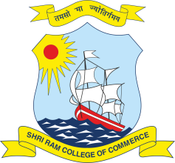 | SHRI RAM COLLEGE OF COMMERCE University of Delhi, Maurice Nagar, Delhi – 110 007 Website: www.srcc.edu Phone: 27667905, 27666519
 | December 17, 2020
The internal assessment marks have been uploaded to the college’s website. UG students of semester 3 and semester 5 are hereby directed to check the same and report discrepancy if any, via email to internal.assessment@srcc.du.ac.in latest by 21st December 2020, 03:00 P.M, clearly stating below mentioned fields:
1. Name of the Course
2. Name of the Student
3. Examination Roll Number
4. College Roll Number (as on Identity Card)
5. Section
6. Name of the Paper in which Issue is to be reported
7. Name of Faculty Concerned
8. Remarks/Issue

Above mentioned data shall be repeated for reporting multiple discrepancies.

(Prof. Simrit Kaur)
Principal

