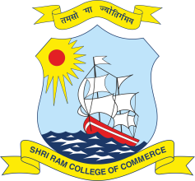 | SHRI RAM COLLEGE OF COMMERCE  University of Delhi, Maurice Nagar, Delhi – 110 007  Website: www.srcc.edu Phone: 27667905, 27666519

May 1, 2021

Extension of Last Date

With reference to the advertisement dated 08.04.2021 and notice dated 24.04.2021 for the post of Administrative Officer on Deputation Basis the last date for submission of application has been extended till 10.05.2021.

Prof. Simrit Kaur
Principal

