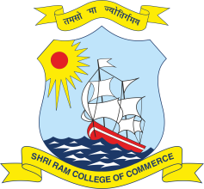 | SHRI RAM COLLEGE OF COMMERCE  University of Delhi, Maurice Nagar, Delhi – 110 007  Website: www.srcc.edu Phone: 27667905, 27666519

April 24, 2021

CORRIGENDUM

With reference to the advertisement dated 08.04.2021 for the post of Administrative Officer on Deputation Basis the last date for submission of application has now been extended till 01.05.2021.

PRINCIPAL

