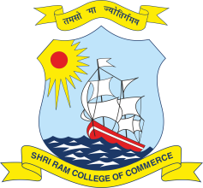 | SHRI RAM COLLEGE OF COMMERCE  University of Delhi, Maurice Nagar, Delhi – 110 007  Website: www.srcc.edu Phone: 27667905, 27666519
June 26, 2020

NOTICE
Internal Assessment of CIC students studying in SRCC has been uploaded to the college’s website. All concerned CIC students are hereby directed to check the same and report discrepancy if any, to sonu.gupta@srcc.du.ac.in latest by 28th June 2020, 03:00. PM, strictly in the format below:
CIC Roll No
Name
Subject in which discrepancy is to be reported
Name of the faculty concerned
Remark

Above mentioned data shall be repeated in case of multiple discrepancies.

(Prof. Simrit Kaur)
Principal

